**The University of California, Santa Cruz**

Baskin School of Engineering

Project Proposal:

**UCSC ARC CPOL Antenna and DTMF Control**

Team Members:

Chris Tatosian

Timothy Bodkin

Luis Ceja

Kevin Helms

# **Abstract**

Our mission is to design, characterize, and implement a circularly polarized antenna to increase the UCSC AC6P Repeater range and to mitigate multipath interference in troublesome areas. The antenna will be interfaced with the repeater via DTMF protocol, allowing for smooth switching between the current linearly polarized antenna and the circularly polarized antenna wirelessly, from a portable radio. Echolink and IRLP nodes will be integrated into the current system with our DTMF controller, allowing worldwide access to our repeater.

# **Proposal**

The initial phase of the antenna design will consist of thoroughly reviewing the single-element simulations done by last year’s senior design group. The goal is to improve the design, verify simulations, and specify design changes that will lead to a successful proof-of-concept prototype. This will include radiation patterns and impedance vs. frequency measurements using the VNA and designing the necessary 50 Ohm impedance matching network. The single element antenna will be expanded into a multi-element CP antenna, achieving a field gain similar to the existing 7/8 wave vertical antenna mechanically stable and designed for long term usage.

The DTMF controller design will begin with a thorough review of last year’s design and will lead to the necessary design improvements and expansion to include additional ports for IRLP and Echolink nodes that will allow worldwide access to the repeater upon joining the UCSC ARC. The controller will be capable of processing codes to enable IRLP or Echolink, and allow for switching between the circularly antenna and vertically polarized antenna.

# **Block Diagram**

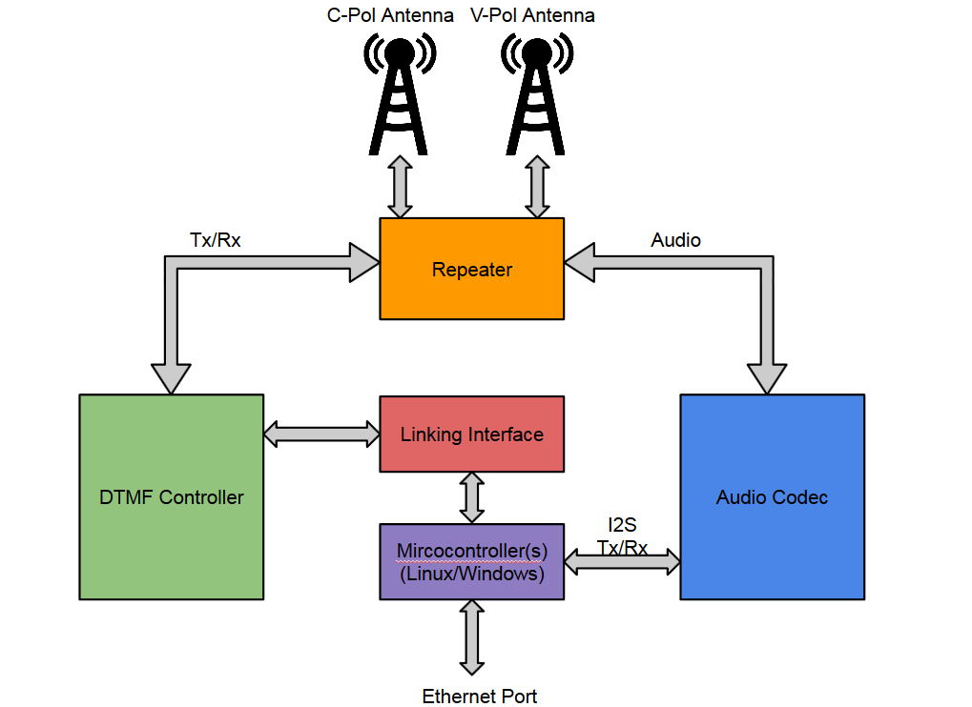

**DTMF Controller**: Designed to accept coded touch tones to switch between our current linearly polarized antenna and our circularly polarized antenna, as well as enabling of the Echo-link and IRLP nodes.

**Audio Codec**: Digitizes, and encodes digital audio for data transmission via Ethernet port

**Microcontrollers**: Used in the Echo-link, and IRLP nodes.

**Linking Interface**: Communicates with the DTMF controller as a means of controlling active communication ports (specifically, the Echo-link, and IRLP nodes).

# **Deliverables**

## **Winter Quarter, 2015**

We will have thoroughly reviewed the previous design and simulation components of last year’s antenna as well as prototypes for both the antenna and DTMF controller. Simulations will begin to be confirmed and preliminary designs for Echo-link and IRLP nodes will be completed.

## **Spring Quarter, 2015**

We will implement entire system with enough time to test thoroughly in various locations to compare signal strength between circular and vertical antennas as well as match field gain. Impedance measurements of antenna will be made with varying frequency. DTMF controller will be optimized and Echo-link/IRLP nodes implemented.

# 

# **Team and Qualifications**

**Tim Grat Bodkin** *Undergraduate Computer Engineer – University of California Santa Cruz*  *Team Lead*

Tim is a senior majoring in Computer Engineering, with a focus of digital hardware design, with a minor focus in Electrical Engineering. Tim's experience includes software, and embedded system design, analog electronics, PCB design, hardware design, and working with digital audio, and audio electronics. Interests mainly reside in audio and DSP applications.

**Chris Tatosian** *Undergraduate Electrical Engineer – University of California Santa Cruz* *Assistant Team Lead*

Chris is a senior studying Electrical Engineering. Has an undergraduate focus in analog electronic design with experience in analog RF and Microwave hardware design, PCB design and antenna theory. Interests in physics (EM/quantum), audio electronics, RF and IC design as well as materials science. Chris is currently working as an undergraduate researcher in Nobuhiko Kobayashi’s materials science lab NECTAR (Nanostructured Energy Conversion Technology and Research) characterizing nanomaterials.

**Luis Ceja**  *Undergraduate Electrical Engineer - University of California Santa Cruz*

Senior studying Electrical Engineering with a focus in optics, and electronics with experience in PCB design, software design for embedded systems, and hardware design. Interests mainly include hardware applications and electronics.

**Kevin Helms** *Undergraduate Electrical Engineer and Computer Engineer - University of California Santa Cruz*

Senior undergraduate student double majoring in both Electrical Engineering, with a focus in Electronics and Optics, and Computer Engineering, with a focus in Digital Hardware. Has experience with power engineering, PCB design, embedded system design, and analog electronic design. Interests include RF design, communication systems, and electromagnetic waves.

# **Conclusion**

Our goal is to design and implement a circularly polarized (CPOL) antenna for the UCSC amateur radio repeater along with a dual tone multiple frequency controller with capabilities of antenna switching and activation of Echo-link and IRLP nodes.